GARAGE MANAGEMENT SYSTEM

**COLLEGE NAME:** Sri Krishna Adithya College of Arts and Science

**COLLEGE CODE:** BRUAG

**TEAM ID:** NM2025TMID22683

**TEAM MEMBER:**

**TEAM HEAD:** RAGHUL K

**EMAIL:** 23bsct142raghulk@skacas.ac.in

**TEAM MEMBER 1:** DHARSHINI M

**EMAIL:** 23bsct112dharshinim@skacas.ac.in

**TEAM MEMBER 2:** SANJANA S

**EMAIL:** 23bsct153sanjanas@skacas.ac.in

**TEAM MEMBER 3:** SANJAY K

**EMAIL:** 23bsct154sanjayk@skacas.ac.in

**PROJECT OVERVIEW – GARAGE MANAGEMENT SYSTEM**

**1. Project Title**

Garage Management System (GMS)

**2. Project Objective**

The objective of this project is to design and implement a system that streamlines daily garage operations. It helps manage customer details, vehicle records, service bookings, spare parts inventory, billing, and employee tasks, ensuring efficiency, accuracy, and better customer satisfaction.

**3. Project Scope**

The system will:

* Store customer and vehicle details in a centralized database.
* Allow booking of vehicle servicing and repairs.
* Track the status of vehicles (in-progress, completed, delivered).
* Manage spare parts inventory (stock availability, usage, reordering).
* Generate invoices and maintain payment records.
* Provide reporting and analytics (e.g., revenue, most-used services, pending jobs).

**4. Key Features**

* **Customer Management** – Add/update customer details and history.
* **Vehicle Management** – Record vehicle details (type, model, registration number, etc.).
* **Service Management** – Schedule and track service/repair jobs.
* **Inventory Management** – Maintain stock of spare parts and consumables.
* **Billing System** – Auto-generate bills and track payments.
* **User Management** – Different access levels (Admin, Mechanic, Receptionist, etc.).
* **Reports & Analytics** – Service history, revenue reports, parts usage, etc.

**5. Users of the System**

* **Garage Owner / Admin** – Full access and management.
* **Mechanics / Technicians** – Access assigned service jobs and update status.
* **Receptionist / Front Desk Staff** – Manage bookings, customer communication, and billing.
* **Customers (optional via portal/mobile app)** – Book services and check status.

**6. Benefits**

* Streamlined garage operations with reduced manual paperwork.
* Faster service booking and processing.
* Accurate billing and inventory control.
* Improved customer experience and trust.
* Data-driven decision making through reports.

**7. Technology Stack (example)**

* **Frontend:** HTML, CSS, JavaScript / React
* **Backend:** Java / Python / Node.js / PHP
* **Database:** MySQL / PostgreSQL / MongoDB
* **Deployment:** Cloud or On-premises
* **Optional:** Mobile App (Android/iOS)

**8. Deliverables**

* A functional Garage Management System application.
* User documentation and training guide.
* Test cases and reports.
* Deployment and maintenance plan.

**MILESTONE 1: SALESFORCE**

**ACTIVITY 1: CREATING DEVELOPER ACCOUNT**

**Creating a developer org in salesforce.**

1. Go to <https://developer.salesforce.com/signup>
2. On the sign up form, enter the following details:

](https://developers.salesforce.com/Signup*)

1. First name & Last name
2. Email
3. Role: Developer
4. Company: College Name
5. County: India
6. Postal Code: pin code
7. Username: should be a combination of your name and company

This need not be an actual email id,   
you can give anything in the format: username@organization.com

Click on sign me up after filling these.

**ACTIVITY 2: ACCOUNT ACTIVATION**

1. Go to the inbox of the email that you used while signing up. Click on the verify account to activate your account. The email may take 5-10mins.

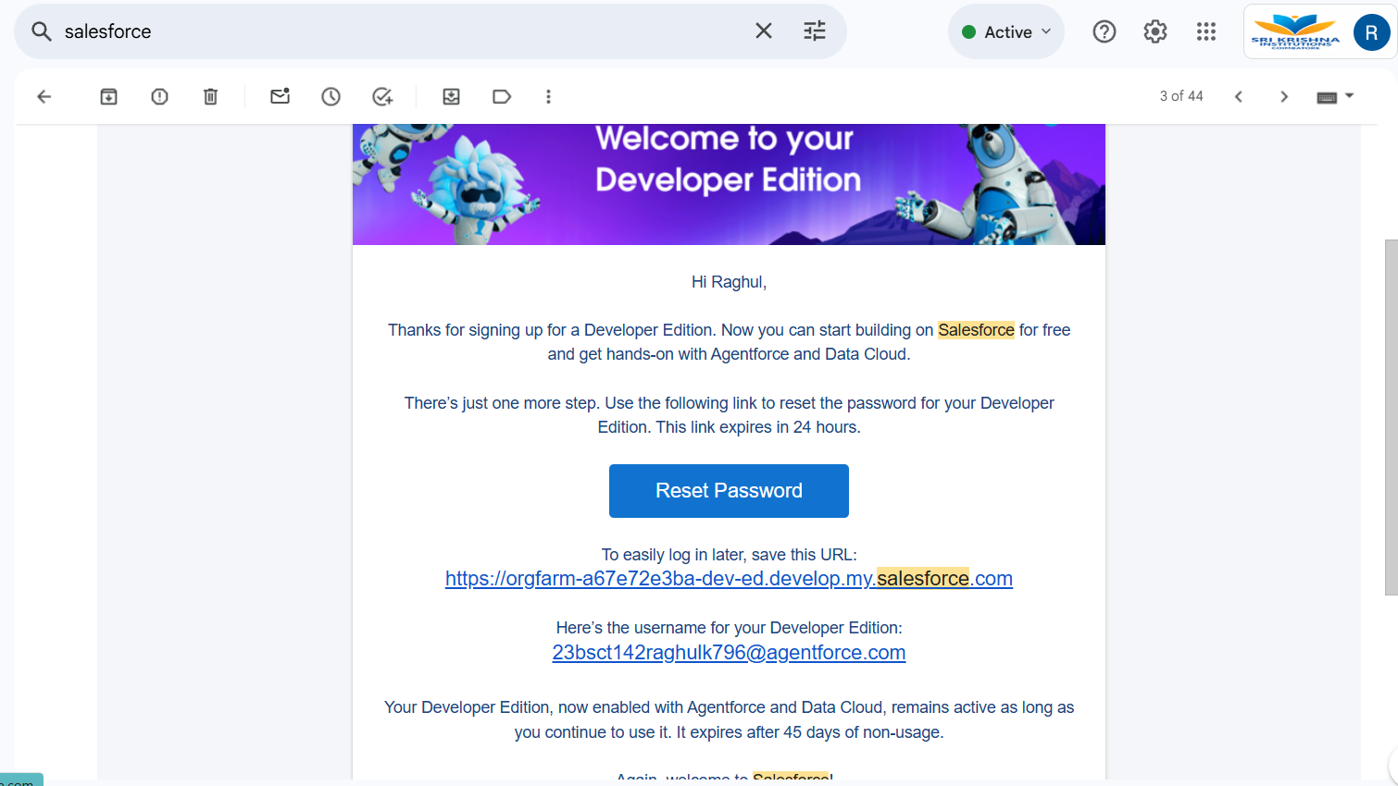

1. Click on Verify Account
2. Give a password and answer a security question and click on change password.

1. Then you will redirect to your salesforce setup page.

**MILESTONE 2: OBJECT**

**ACTIVITY 1: *Create Customer DetailsObject***

To create an object:

1. From the setup page >> Click on Object Manager >> Click on Create >> Click on Custom Object.
2. Enter the label name >> Customer Details
3. Plural label name >> Customer Details
4. Enter Record Name Label and Format

* Record Name >> Customer Name
* Data Type >> Text

1. Click on Allow reports and Track Field History,
2. Allow search >> Save.

**ACTIVITY 2:** **Create Appointment Object**

To create an object:

1. From the setup page >> Click on Object Manager >> Click on Create >> Click on Custom Object.
2. Enter the label name >> Appointment
3. Plural label name >> Appointments
4. Enter Record Name Label and Format

* Record Name >> Appointment Name
* Data Type >> Auto Number
* Display Format >> app-{000}
* Starting number >> 1

1. Click on Allow reports and Track Field History,
2. Allow search >> Save.

**ACTIVITY 3: CREATE SERVICE RECORD OBJECT**

To create an object:

1. From the setup page >> Click on Object Manager >> Click on Create >> Click on Custom Object.
2. Enter the label name >> Service records
3. Plural label name >> Service records
4. Enter Record Name Label and Format

* Record Name >>Service records Name
* Data Type >> Auto Number
* Display Format >> ser-{000}
* Starting number >> 1

1. Click on Allow reports and Track Field History,
2. Allow search >> Save.

**ACTIVITY 4: Create Billing details and feedback Object**

To create an object:

1. From the setup page >> Click on Object Manager >> Click on Create >> Click on Custom Object.
2. Enter the label name >> Billing details and feedback
3. Plural label name >> Billing details and feedback
4. Enter Record Name Label and Format

* Record Name >> Billing details and feedback Name
* Data Type >> Auto Number
* Display Format >> bill-{000}
* Starting number >> 1

1. Click on Allow reports and Track Field History,
2. Allow search >> Save.

**MILESTONE 3: TABS**

**ACTIVITY 1: CREATING A CUSTOM TAB**

**To create a Tab: (Customer Details)**

1. Go to setup page >> type Tabs in Quick Find bar >> click on tabs >> New (under custom object tab)

1. Select Object (Customer Details) >> Select the tab style >> Next (Add to profiles page) keep it as default >> Next (Add to Custom App) uncheck the include tab.
2. Make sure that the Append tab to users' existing personal customizations is checked.
3. Click save.

**ACTIVITY 2: CREATING REMAINING TABS**

1. Now create the Tabs for the remaining Objects, they are “Appointments, Service records, Billing details and feedback”.
2. Follow the same steps as mentioned in Activity -1.

**MILESTONE 4: THE LIGHTING APP**

**ACTIVITY 1: CREATE A LIGHTING APP**

To create a lightning app page:

1. Go to setup page >> search “app manager” in quick find >> select “app manager” >> click on New lightning App.

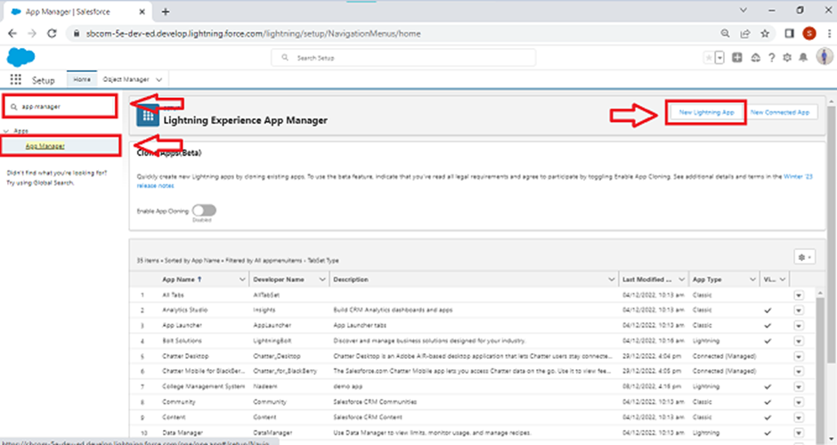

1. Fill the app name in app details as Garage Management Application >> Next >> (App option page) keep it as default >> Next >> (Utility Items) keep it as default >> Next.  
   A screenshot of a computer

   AI-generated content may be incorrect.
2. To Add Navigation Items: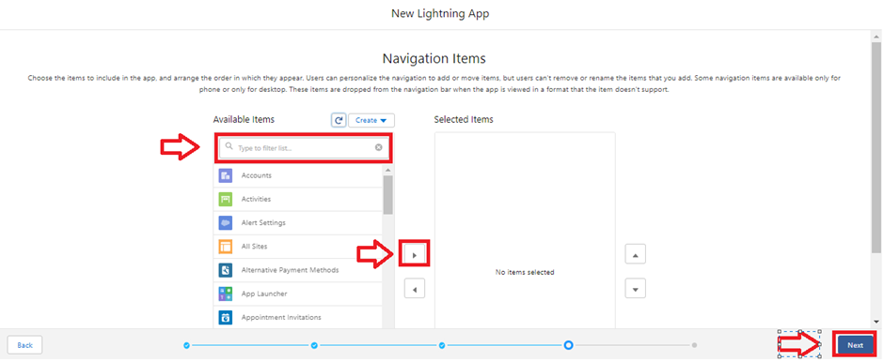
3. Select the items (Customer Details, Appointments, Service records, Billing details and feedback, Reports and Dashboards) from the search bar and move it using the arrow button>> Next.
4. To Add User Profiles:

Search profiles (System administrator) in the search bar >> click on the arrow   
button >> save & finish.

MILESTONE 5:FIELDS

**ACTIVITY 1: Creation of fields for the Customer Details object**

**. To create fields in an object:**

1. Go to setup >> click on Object Manager >> type object name (Customer Details) in search bar >> click on the object.

1. Now click on “Fields & Relationships” >> New

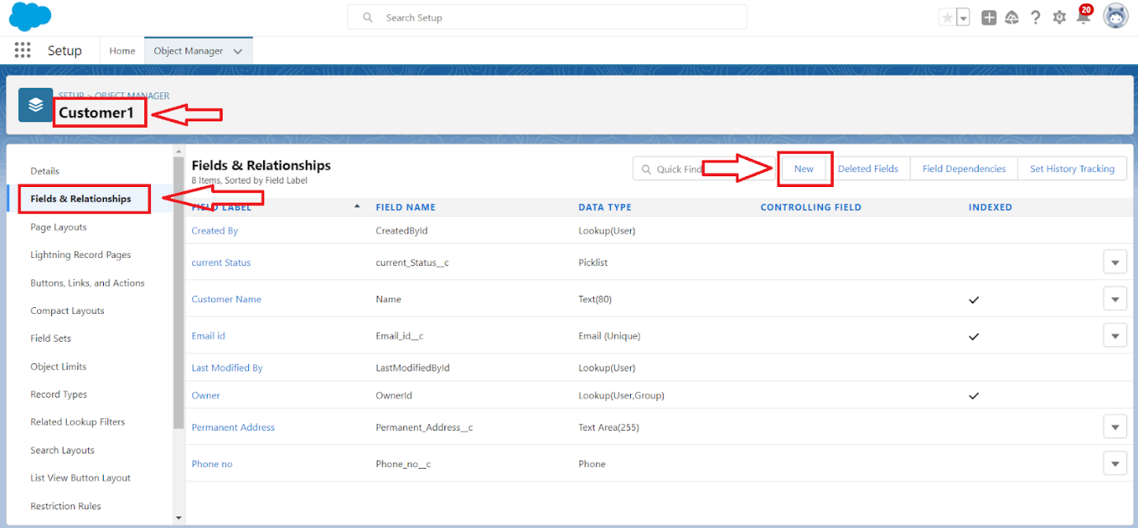

1. Select Data Type as a “Phone”

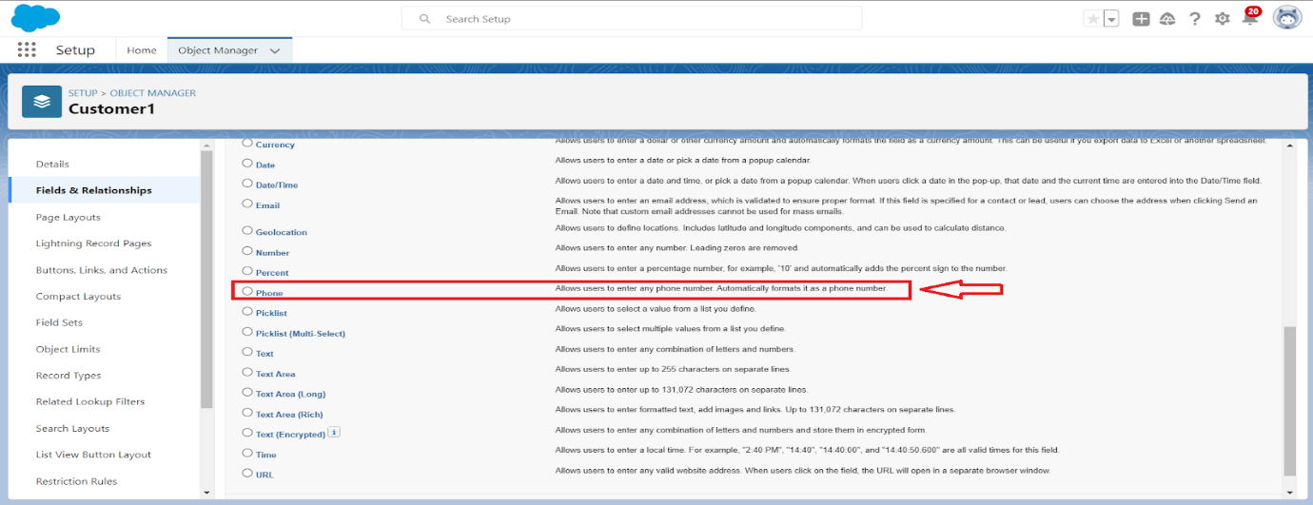

1. Click on next.

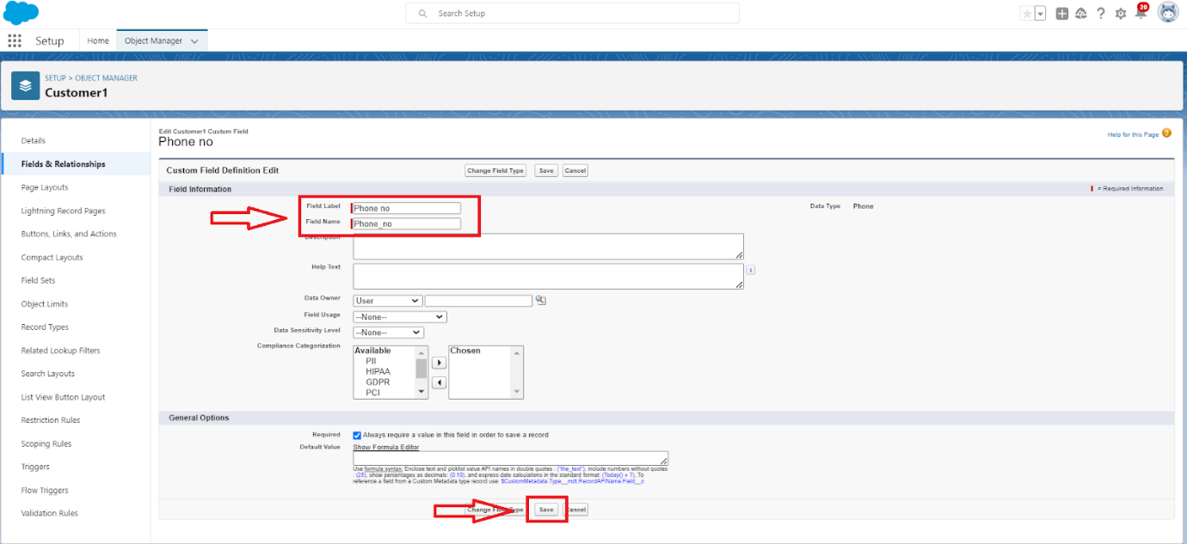

5. Fill the Above as following:

* Field Label: Phone number
* Field Name: gets auto generated
* Click on Next >> Next >> Save and new.

Note: Follow the above steps for the remaining field for the same object.

**2. To create another fields in an object:**

1. Go to setup >> click on Object Manager >> type object name (Customer Details) in search bar >> click on the object.
2. Now click on “Fields & Relationships” >> New
3. Select Data type as a “Email” and Click on Next
4. Fill the Above as following:

* Field Label: Gmail
* Field Name: gets auto generated
* Click on Next >> Next >> Save and new.

**ACTIVITY 2: Creation of Lookup Fields**

**Creation of Lookup Field on Appointment Object:**

1. Go to setup >> click on Object Manager >> type object name (Appointment) in the search bar >> click on the object.

1. Now click on “Fields & Relationships” >> New

1. Select “Look-up relationship” as data type and click Next.

1. Select the related object “Customer Details” and click next.
2. Next >> Next >> Save.

**Note: Make sure you complete Activity 4 Before continuing.**

**Creation of Lookup Field on Service records Object:**

1. Go to setup >> click on Object Manager >> type object name (Service records) in search bar >> click on the object.
2. Now click on “Fields & Relationships” >> New
3. Select “Look-up relationship” as data type and click Next.
4. Select the related object “Appointment” and click next.
5. Make it a required field so click on Required.

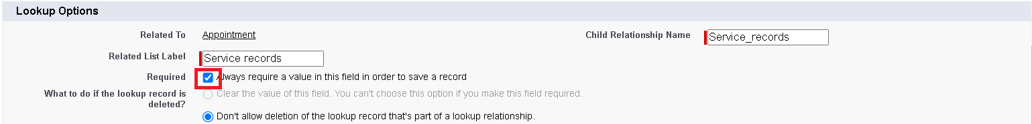

1. Scroll down for Lookup Filter and click on Show filter settings.
2. Now add the filter criteria.
3. Field: Appointment: Appointment Date >> Operator: less than >> select field >> Appointment: Created Date
4. Filter type should be Required.

1. Error Message: Value does not match the criteria.
2. Enable the filter by click on Active.
3. Next >> Next >> Save.

**Creation of Lookup Field on Billing details and feedback Object:**

1. Go to setup >> click on Object Manager >> type object name (Billing details and feedback) in search bar >> click on the object.
2. Now click on “Fields & Relationships” >> New.
3. Select “Look-up relationship” as data type and click Next.
4. Select the related object “Service records” and click next.
5. Next >> Next >> Save & new.

**ACTIVITY 3: Creation of Checkbox Fields**

**Creation of Checkbox Field on Appointment Object:**

1. Go to setup >> click on Object Manager >> type object name (Appointment) in search bar >> click on the object.
2. Now click on “Fields & Relationships” >> New.
3. Select “Check box” as data type and click Next.

1. Give the Field Label: Maintenance service
2. Field Name: is auto populated
3. Default value: unchecked

1. Click on next >> next >> save.

**Creation of Another Checkbox Field on Appointment Object:**

1. Repeat the steps form 1 to 3.
2. Give the Field Label: Repairs
3. Field Name: is auto populated
4. Default value: unchecked
5. Click on next >> next >> save.
6. Follow the same and create another checkbox with given names
7. Give the Field Label: Replacement Parts
8. Field Name: is auto populated
9. Default value: unchecked
10. Click on next >> next >> save.

**Creation of Checkbox Field on Service records Object:**

1. Go to setup >> click on Object Manager >> type object name (Service records) in search bar >> click on the object.
2. Now click on “Fields & Relationships” >> New.
3. Select “Check box” as data type and click Next.
4. Give the Field Label: Quality Check Status
5. Field Name: is auto populated
6. Default value: unchecked
7. Click on next >> next >> save

**ACTIVITY 4: Creation of date Fields**

**Creation of Date Field on Appointment Object:**

1. Go to setup >> click on Object Manager >> type object name (Appointment) in the search bar >> click on the object.
2. Now click on “Fields & Relationships” >> New.
3. Select “Date” as data type and click Next.
4. Give the Field Label: Appointment Date
5. Field Name: is auto populated
6. Make it as a Required field by click on the Required option.
7. Click on next >> next >> save.

**ACTIVITY 5: Creation of Currency Fields**

**Creation of Currency Field on Appointment Object:**

1. Go to setup >> click on Object Manager >> type object name (Appointment) in the search bar >> click on the object.
2. Now click on “Fields & Relationships” >> New.
3. Select “Currency” as data type and click Next.
4. Give the Field Label: Service Amount
5. Field Name: is auto populated

1. Click on next
2. Give read only for all the profiles in field level security for profile.

1. Click on next > > save.

**Creation of Currency Field on Billing details and feedback Object:**

1. Follow the same steps as mentioned above in Billing details and feedback Object.
2. Change the label name as mentioned.
3. Give the Field Label: Payment Paid
4. Field Name: is auto populated

**ACTIVITY 6: Creation of Text Fields**

1. Go to setup >> click on Object Manager >> type object name (Appointment) in the search bar >> click on the object.
2. Now click on “Fields & Relationships” >> New.
3. Select “Text” as data type and click Next.
4. Give the Field Label: Vehicle number plate
5. Field Name: is auto populated
6. Length: 10
7. Make field as Required and Unique.

1. Click on next >> next >> save.

**Creation of Text Fields in Billing details and feedback object:**

1. Go to setup >> click on Object Manager >> type object name (Billing details and feedback) in search bar >> click on the object.
2. Now click on “Fields & Relationships” >> New.
3. Select “text” as data type and click Next.
4. Give the Field Label: Rating for service
5. Field Name: is auto populated
6. Length: 1
7. Make field as Required.
8. Click on next >> next >> save

**ACTIVITY 7: Creation of Picklist Fields**

**Creation of Picklist Fields in Service records object:**

1. Go to setup >> click on Object Manager >> type object name (Service records) in search bar >> click on the object.
2. Click on fields & relationship >> click on New.
3. Select Data type as “Picklist” and click Next.
4. Enter Field Label as “Service Status”, under values select “Enter values, with each value separated by a new line" and enter values as shown below.
5. The values are: Started, Completed.

1. Click Next.
2. Next >> Next >> Save.

**Creation of Picklist Fields in Billing details and feedback object:**

1. Go to setup >> click on Object Manager >> type object name (Billing details and feedback) in search bar >> click on the object.
2. Click on fields & relationship >> click on New.
3. Select Data type as “Picklist” and click Next.
4. Enter Field Label as “Payment Status”, under values select “Enter values, with each value separated by a new line" and enter values as shown below.
5. The values are: Pending, Completed.
6. Click Next.
7. Next >> Next >> Save.

**ACTIVITY 8: Creating Formula Field in Service records Object**

1. Go to setup >> click on Object Manager >> type object name (Service records) in search bar >> click on the object.
2. Click on fields & relationship >> click on New.
3. Select Data type as “Formula” and click Next.
4. Give Field Label and Field Name as “service date” and select formula return type as “Date” and click next.

1. Insert field formula should be: Created Date

1. click “Check Syntax”.
2. Click next >> next >> Save.

**MILESTONE 5: VALIDATION RULE**

**ACTIVITY 1: To create a validation rule to an Appointment Object**

1. Go to the setup page >> click on object manager >> From drop down click edit for Appointment object.
2. Click on the validation rule >> click New.

1. Enter the Rule name as “Vehicle”.
2. Insert the Error Condition Formula as: -

NOT (REGEX (Vehicle_number_plate__c , "[A-Z]{2}[0-9]{2}[A-Z]{2}[0-9]{4}"))

1. Enter the Error Message as “Please enter vaild number ”, select the Error location as Field and select the field as “Vehicle number plate”, and click Save.

**ACTIVITY 2: To create a validation rule to an Billing details and feedback Object**

1. Go to the setup page >> click on object manager >> From drop down click edit for Billing details and feedback object.
2. Click on the validation rule >> click New.
3. Enter the Rule name as “rating_should_be_less_than_5”.
4. Insert the Error Condition Formula as: -

NOT (REGEX (Rating_for_service__c , "[1-5]{1}"))

1. Enter the Error Message as “rating should be from 1 to 5”, select the Error location as Field and select the field as “Rating for Service”, and click Save.

MILESTONE 6:DUPLICATE RULE

**ACTIVITY 1: To create a matching rule to an Customer details Object**

1. Go to quick find box in setup and search for matching Rule.
2. Click on matching rule >> click on New Rule.

1. Select the object as Customer details and click Next.

1. Give the Rule name: Matching customer details
2. Unique name: is auto populated
3. Define the matching criteria as
4. Field & Matching Method

1. Gmail Exact

2. Phone Number Exact

1. Click save.
2. After Saving Click on Activate.

**ACTIVITY 2: To create a Duplicate rule to an Customer details Object**

1. Go to quick find box in setup and search for Duplicate rules.
2. Click on Duplicate rule >> click on New Rule >> select customer details object.

1. Give the Rule name as: Customer Detail duplicate
2. Scroll a little in Matching rule section
3. Select the matching rule: Matching customer details
4. And Click on save.
5. After saving the Duplicate Rule, Click on Activate.

MILESTONE 8:PROFILE

**ACTIVITY 1:MANAGER PROFILE**

**To create a new profile:**

1. Go to setup >> type profiles in quick find box >> click on profiles >> clone the desired profile (Standard User) >> enter profile name (Manager) >> Save.

1. While still on the profile page, then click Edit.

1. Select the Custom App settings as default for the Garage management.

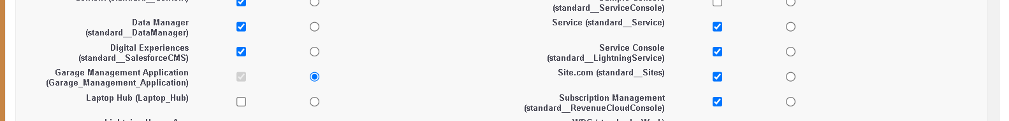

1. Scroll down to Custom Object Permissions and Give access permissions for Appointments,Billing details and feedback , service records and customer details objects as mentioned in the below diagram.

1. Changing the session times out after should be “8 hours of inactivity”.
2. Change the password policies as mentioned:
3. User passwords expire in should be “never expires ”.
4. Minimum password length should be “8 ”, and click save.

**ACTIVITY 2:SALES PERSON PROFILE**

1. Go to setup >> type profiles in quick find box >> click on profiles >> clone the desired profile (Salesforce Platform User) >> enter profile name (sales person) >> Save.
2. While still on the profile page, then click Edit.
3. Select the Custom App settings as default for the GArage management.
4. Scroll down to Custom Object Permissions and Give access permissions for Appointments,Billing details and feedback , service records and customer details objects as mentioned in the below diagram.

1. And click save.

MILESTONE 9:Role&RoleHierarchy

**ACTIVITY 1:CREATING MANAGER ROLES**

Creating Manager Role:

1. Go to quick find >> Search for Roles >> click on set up roles.

1. Click on Expand All and click on add role under whom this role works.

1. Give Label as “Manager” and Role name gets auto populated. Then click on Save.

**ACTIVITY 2:CREATING ANOTHER ROLES**

Creating another two roles under manager

1. Go to quick find >> Search for Roles >> click on set up roles.
2. Click plus on CEO role, and click add role under manager.

1. Give Label as “sales person” and Role name gets auto populated. Then click on Save.

MILESTONE 10:USERS

**ACTIVITY 1: CREATE USER**

1. Go to setup >> type users in quick find box >> select users >> click New user.
2. Fill in the fields
3. First Name: Niklaus
4. Last Name: Mikaelson
5. Alias: Give a Alias Name
6. Email id: Give your Personal Email id
7. Username: Username should be in this form: text@text.text
8. Nick Name: Give a Nickname
9. Role: Manager
10. User licence: Salesforce
11. Profiles: Manager

1. Save.

**ACTIVITY 2:CREATING ANOTHER USERS**

1. Repeat the steps and create another user using
   1. Role: sales person
   2. User licence: Salesforce Platform
   3. Profile: sales person

**Note: create atleast 3 users with these permissions.**

MILESTONE 11:PUBLIC USERS

**ACTIVITY: CREATING NEW PUBLIC GROUP**

1. Repeat the steps and create another user using
   1. Role: sales person
   2. User licence: Salesforce Platform
   3. Profile: sales person

**Note: create atleast 3 users with these permissions.**

MILESTONE 12: SHARING SETTING

**ACTIVITY: CREATING SHARING SETTING**

1. Go to setup >> type users in quick find box >> select Sharing Settings >> click Edit.
2. Change the OWD setting of the Service records Object to private as shown in fig.

1. Click on save and refresh.
2. Scroll down a bit, Click new on Service records sharing Rules.



1. Give the Label name as “Sharing setting”
2. Rule name is auto populated.
3. In step 3: Select which records to be shared, members of “Roles ” >> “Sales person”
4. In step 4: share with, select “Roles ” >> “Manager ”
5. In step 5: Change the access level to “Read / write ”.
6. Click on save.

MILESTONE 13: FLOWS

**ACTIVITY 1: CREATE A FLOW**

1. Go to setup >> type Flow in quick find box >> Click on the Flow and Select the New Flow.

1. Select the Record-triggered flow and Click on Create.

1. Select the Object as “Billing details and feedback”in the Drop down list.
2. Select the Trigger Flow when: “A record is Created or Updated”.
3. Select the Optimize the flow for: “Actions and Related Records” and Click on Done.

1. Under the Record-triggered Flow Click on “+” Symbol and In the Drop down List select the “Update records Element”.

1. Give the Label Name: Amount Update
2. Api name: is auto populated

1. Set a filter condition: All Conditions are met (AND)
2. Field: Payment_Status__c
3. Operator: Equals
4. Value: Completed
5. And Set Field Values for the Billing details and feedback Record
6. Field: Payment_Paid__c
7. Value: {!$Record.Service_records__r.Appointment__r.Service_Amount__c}
8. Click On Done.
9. Before creating another Element. Create a New Resource form Toolbox form top left.

1. Click on the New Resource, And select Variable.
2. Select the resource type as text template.
3. Enter the API name as “alert”.
4. Change the view as Rich Text ? View to Plain Text.
5. In body field paste the syntax that given below.

Dear {!$Record.Service_records__r.Appointment__r.Customer_Name__r.Name},

I hope this message finds you well. I wanted to take a moment to express my sincere gratitude for your recent payment for the services provided by our garage management team. Your prompt payment is greatly appreciated, and it helps us continue to provide top-notch services to you and all our valued customers.

Amount paid: {!$Record.Payment_Paid__c}

Thank you for Coming .

1. Click done.

1. Now Click on Add Element , select Action.
2. Their action bar will be opened in that search for “send email ” and click on it.
3. Give the label name as “Email Alert”
4. API name will be auto populated.
5. Enable the body in set input values for the selected action.
6. Select the text template that created , Body: {!alert}
7. Include recipient address list select the email form the record.
8. RecipientAddressList: {!$Record.Service_records__r.Appointment__r.Customer_Name__r.Gmail__c}
9. Include subject as “Thank You for Your Payment - Garage Management”.
10. Click done.

1. Click on save. Give the Flow label , Flow Api name will be autopopulated.
2. And click save, and click on activate.

**ACTIVITY 2: CREATE ANOTHER FLOW**

* 1. Go to setup ? type Flow in quick find box ? Click on the Flow and Select the New Flow.

* 1. Select the Record-triggered flow and Click on Create.

* 1. Select the Object as “**Service records**”in the Drop down list.
  2. Select the Trigger Flow when: “A record is Created or Updated”.
  3. Select the Optimise the flow for: “Actions and Related Records” and Click on Done.
  4. Under the Record-triggered Flow Click on “+” Symbol and In the Drop down List select the “Update records Element”.
  5. Set a filter condition: All Conditions are met (AND)
  6. Field: **Quality_Check_Status__c**
  7. Operator: **Equals**
  8. Value: **True**
  9. And Set Field Values for the Billing details and feedback Record
  10. Field: **Service_Status__c**
  11. Value: **Completed**

* 1. Click On **Done**.
  2. Click on **save**
  3. Given the Flow label as**Update Service Status** , Flow Api name will be auto populated.
  4. And click save, and click on **activate**.

MILESTONE 14: APEX TRIGGER

**ACTIVITY: APEX HANDLER**

UseCase: This use case works for Amount Distribution for each Service the customer selected for there Vehicle.

1. Login to the respective trailhead account and navigate to the gear icon in the top right corner.
2. Click on the Developer console. Now you will see a new console window.
3. In the toolbar, you can see FILE. Click on it and navigate to new and create New apex class.
4. Name the class as “AmountDistributionHandler ”.

MILESTONE 15: REPORTS

**ACTIVITY 1: CREATE A REPORTS FOLDER**

1. Click on the app launcher and search for reports.
2. Click on the report tab, click on new folder.

1. Give the Folder label as “Garage Management Folder”, Folder unique name will be auto populated.
2. Click save.

**ACTIVITY 2:SHARING A REPORT FOLDER**

1. Go to the app >> click on the reports tab.
2. Click on the All folder , click on the Drop down arrow for Garage Management folder, and Click on share.
3. Select the share with as “roles”, in name field search for “manager”, give “view” as access for that role.
4. Then click share, and click on Done.

**ACTIVITY 3:CREATE RECORD TYPE**

1. Go to setup >> type users in quick find box >> select Report Type >> click on Continue.
2. Click on new custom report type.

1. Select the Primary object as “Customer details” .
2. Give the Report type Label as “Service information ”
3. Report type Name is autopopulated.
4. Keep the Description as same.
5. Select Store in Category as “other Reports ”
6. Select the deployment status as “Depolyed ”, click on Next.

1. now , Click on Related object box.
2. Click on Select Object, choose Appointment Object as shown in fig.

1. Again Click to relate another object.
2. And select the related object as “service records”.
3. Repeat the process and select the related object as “Billing details and feedback”.
4. And click on save.

**ACTIVITY 4:CREATE REPORT**

**Note: Before creating report, create latest “10” records in every object.**

**Try to fill every field in each record for better experience.**

1. Go to the app >> click on the reports tab
2. Click New Report.

1. Select the Category as other reports, search for Service Information, select that report, click on it. And click on start report.

1. Their outline pane is opened alredy, select the fields that mentioned below in column section.
   1. Customer name
   2. Appointment Date
   3. Service Status
   4. Payment paid
2. Remove the unnecessary fields.
3. Select the fields that mentioned below in GROUP ROWS section.
   1. Rating for Service
4. Select the fields that mentioned below in GROUP ROWS section.
   1. Payment Status
5. Click on Add Chart , Select the Line Chart.
6. Click on save, Give the report Name: New Service information Report
7. Report unique Name is auto populated.
8. Select the folder the created and Click on save.

MILESTONE 15: DASHBOARDS

**ACTIVITY 1: CREATING DASHBOARDS FOLDER**

1. Click on the app launcher and search for dashboard.
2. Click on dashboard tab.
3. Click new folder, give the folder label as “Service Rating dashboard”.
4. Folder unique name will be auto populated.
5. Click save.

1. Follow the same steps, from Reports Milestone and Activity 2, and provide the sharing settings for the folder that was just created.

**ACTIVITY 2: CREATE DASHBOARD**

1. Go to the app >> click on the Dashboards tabs.
2. Give a Name and select the folder that created, and click on create.

1. Select add component.



1. Select a Report and click on select.

1. Select the Line Chart. Change the theme.
2. Click Add then click on Save and then click on Done.
3. Preview is shown below.

1. After that Click on Subcribe on top right.
2. Set the Frequency as “weekly ”.
3. Set a day as monday.
4. And Click on save.

MILESTONE 16: USER ADOPTION

**ACTIVITY: CREATING RECORDS**

To create a record in the follow objects follow these steps

1. Click on the app launcher located at the left side of the screen.
2. Search for “**Garage Management**” and click on it.
3. Click on the “**Consumer details** tab”.
4. Click on new and fill the details as shown below figs, and click save.

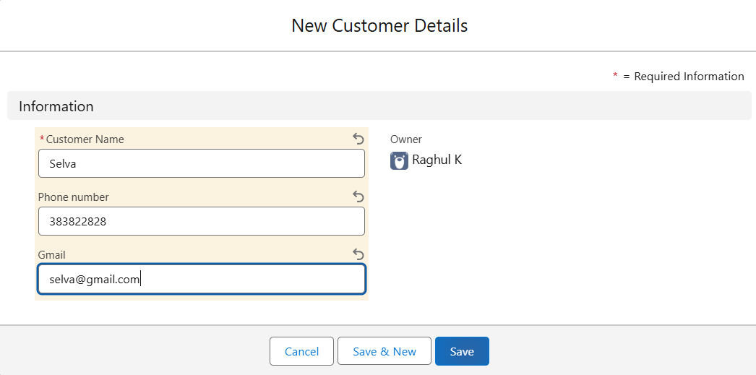

Now, Create the Appointment Record

1. Click on the “**Appointment**tab”.
2. Enter the customer details as created, while entering Appointment Date enter the date less than the created date.
3. Match the validation while entering the vehicle number plate.
4. Select the services you need.
5. Click on save to see the Service Amount.

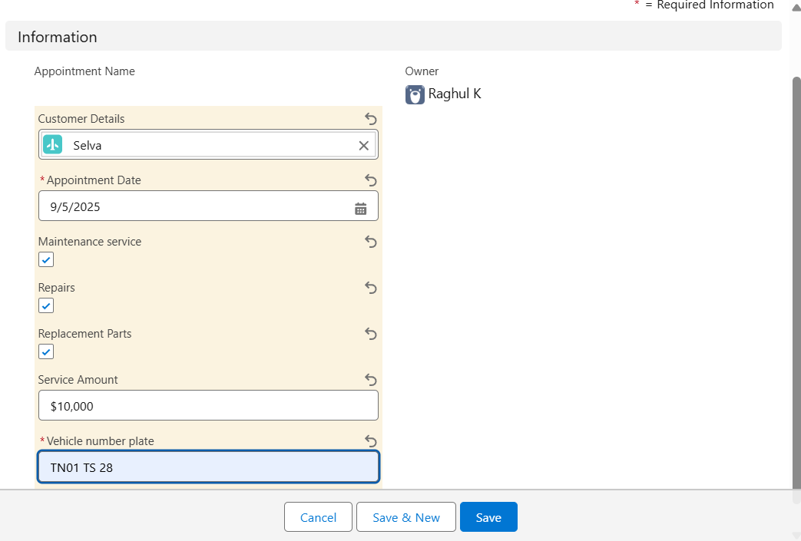

Now, Create a service Record

1. Click on the “**Service record** tab”.
2. Enter the Appointment, and started is selected as default.
3. Click on save.

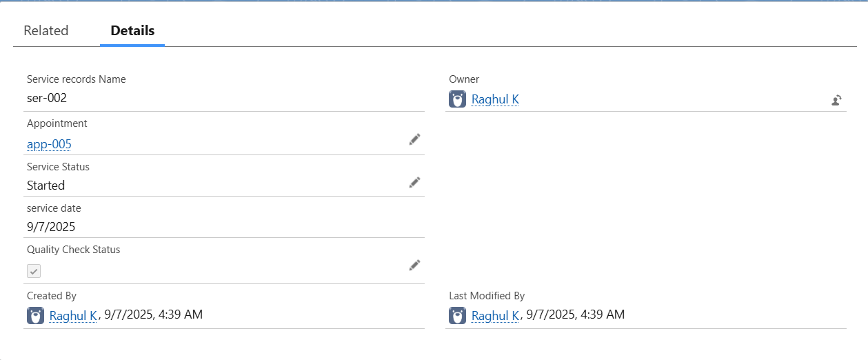

1. Open the record and click on Quality check status as true.
2. Click on save.
3. Now automatically Service status will be moved to completed.

CONCLUSION

The Garage Management System provides an efficient and organized solution for managing day-to-day operations of a garage, including customer records, vehicle details, job assignments, billing, and inventory tracking. By automating manual tasks, the system reduces human errors, saves time, and improves overall productivity. It enhances customer satisfaction through quick service tracking, accurate billing, and transparent communication.

In addition, the system supports better decision-making by generating useful reports and maintaining historical data for future reference. With scalability and adaptability, it can be further enhanced to integrate with online booking, digital payments, and mobile applications.

Overall, the Garage Management System simplifies operations, improves accuracy, and ensures smooth functioning, making it a valuable tool for modern garage businesses.